*From an account written by Giovanni Boccaccio in Florence, Italy.*

“Its earliest symptom was the appearance of fierce swellings in the groin or the armpit, some of which were egg-shaped whilst others were roughly the size of a common apple. People have called these swellings Buboes. By the second day, the victim would violently cough and vomit blood. The following day people have been known to find dark blotches and bruises under their skin, sometimes very large. If the victim was still alive, they could be seen shaking uncontrollably in their beds, screaming to God for relief. By the fifth day, God would finally show his mercy. The swellings might release a foul stench and dark liquid, which would sometimes mean the victim had been spared. But most times death would come swiftly, ending the endless pain and releasing his soul to God’s will.”

*From an account written by Giovanni Boccaccio in Florence, Italy.*

“Its earliest symptom was the appearance of fierce swellings in the groin or the armpit, some of which were egg-shaped whilst others were roughly the size of a common apple. People have called these swellings Buboes. By the second day, the victim would violently cough and vomit blood. The following day people have been known to find dark blotches and bruises under their skin, sometimes very large. If the victim was still alive, they could be seen shaking uncontrollably in their beds, screaming to God for relief. By the fifth day, God would finally show his mercy. The swellings might release a foul stench and dark liquid, which would sometimes mean the victim had been spared. But most times death would come swiftly, ending the endless pain and releasing his soul to God’s will.”

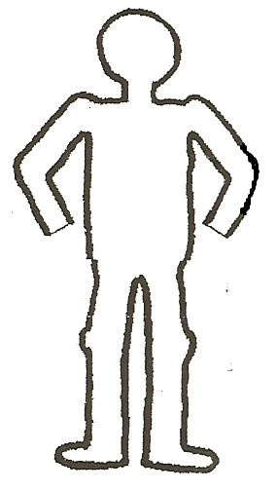

**The Symptoms of the Black Death**